Grain Council calls on private sector players to be part of the change in harmonizing the opportunies, and challenges presented by the Tripartite Free Trade Area (TFTA).

Participants at the 2nd Regional Dialogues on Agribusiness Policy Environment at Ole Sereni Hotel, Nairobi
The 2nd Regional Dialogues on Agribusiness Policy Environment in The Tripartite Free Trade Area (TFTA) member states which brought together the three economic blocs of EAC, SADC and COMESA, governments and private sector players called on to stop interfering with the marketing system by announcing prices through-State Food Reserve Agencies.
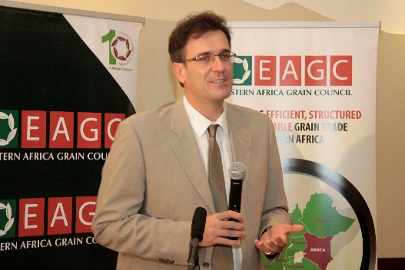
Speaking during the dialogues, Mr. George Mermigkas, Trade Economist, FAO Liaison Office with the United Nations in Geneva, said that TFTA offers oopportunity for regional trade- where the total intraregional trade in staples food is a small fraction of the regions foods imports from outside the region.

The dialogue was hosted n 14th December 2016 in Nairobi by the Eastern Africa Grain Council (EAGC) in partnership with FAO. EAGC released report of the study conducted which finds that most countries in Eastern and Southern Africa region have a comparative advantage in agriculture through the presence of abundant natural resources, large and exploitable yield gaps on the supply chain.

The study outlined recommendations calling on TFTA Member state governments to stop interfering with the marketing system by announcing prices through-State Food Reserve Agencies, ssensitization among policy-makers on the need to maintain free trade of food commodities and its benefits towards long term national food security-with special focus on Parliamentary Agricultural Committee.
The report also recommended that there is need for TFTA member state governments to fully commit to free domestic and regional trade, as well as harmonize the taxes and levies in the grain sector to eliminate and prevent multiple taxation
Speaking during the dialogue, Mr. Gerald Masila, the Executive Director, EAGC said that trade is strategic, purposeful, planned and deliberate hence private sector players especially in the grain sector have key role in engaging in the TFTA processes. “Grain sector players should come forth in engaging in the TFTA processes, lobby for an enabling environment and that is why as EAGC we are committed to this mandate”. He said.
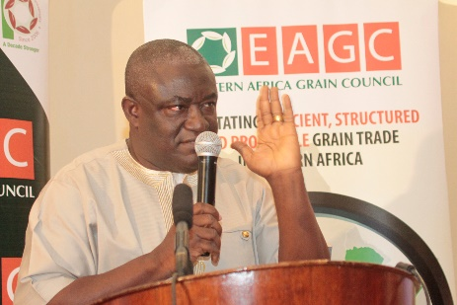
Mr. Harold Ntorinkansah, the Chairman of Africa Rice Advocacy Platform, called on all stakeholders to be part of the change in harnessing the opportunities and challenges presented by the TFTA. Mr. Harold, represented the Africa Rice Advocacy Platform in the meeting.

Mr. Harold Ntorinkansah,

Later in the day, EAGC led by the current Board chairman, Dr. Bernard Otim showcased its milestones in advocating for an enabling environ for the grain in the region in the last ten years of existence. Among the participants in the Tenth Anniversary, were founder members of EA GC and former Executive Director, Ms Constantine Kandie. Ms. Kandie congratulated EAGC for great milestones realized so far. “I am so grateful to see that EAGC has lived its dream in in facilitating an efficient, structured, inclusive and profitable grain trade in the Eastern Africa region and emerging a decade stronger!

USAID, represented by Stephen Orr, Steve Orr, Deputy Chief for Agriculture,
East Africa - Regional Economic Integration Office, acknowledged the great strides EAGC has made since inception back in 2006. USAID was the first development partner to work with EAGC in creating a structured grain markets and market information systems in the region.

Note:
The Tripartite Free Trade Area (TFTA), launched in June 2015, creates the biggest free trade area in Africa by combining the COMESA, EAC and SADC blocs into one free trade area. With 26 Member States and a GDP and population more than half of the entire continent, the TFTA is expected to catalyse economic development in Eastern and Southern Africa through increased trade, infrastructure and industrial development.
It is well known that TFTA countries are not homogeneous and are in fact at different levels of development. Therefore, each TFTA country may have different comparative and/or competitive advantages, which may present opportunities as well as risks during implementation of the TFTA.
In this regard, the Eastern Africa Grain Council (EAGC) with support from the Food and Agriculture Organisation of the United Nations (FAO) conducted a study on agribusiness policy environment in TFTA Member States in the context of risks and opportunities in the TFTA, focusing on regional grain value chains. This study was a follow-up to the study on Agricultural Trade Policy in the TFTA and Implications for Food Security in Eastern and Southern Africa, which was also conducted by EAGC with support from FAO in earlier in 2016.
Key Recommendations of the Study:
The study outlines following recommendations;
- TFTA Member state governments to stop interfering with the marketing system by announcing prices through-State Food Reserve Agencies
- Sensitization among policy-makers on the need to maintain free trade of food commodities and its benefits towards long term national food security-with special focus on Parliamentary Agricultural Committee.
- Need for TFTA member state governments to fully commit to free domestic and regional trade,
- Governments to harmonize the taxes and levies in the grain sector to eliminate and prevent multiple taxation

- Land tenure systems and inaccessibility to credit for agribusiness are two main disincentives in most countries which need to be addressed in order to open up for investor to take advantage of the available opportunities within TFTA.
- Removal of VAT on value added and processed grains to encourage value addition and agro-processing
- Need for development of national and regional agribusiness policies to guide the agribusiness sectors.

